Reco3

# What should be accomplished and what is in place

* New VECTO-version – in place but not tested thoroughly
* New Improvement Manager (Import of new or updated components to Db)
  + Import functionality – In place
  + Update functionality – In place
  + Display component grid (overview) – In place
  + Selecting components from the grid for deletion – In place
* A graphical interface (probably an add-on to the Improvement Manager) for handling the end-data when a simulation is performed. Today that is done through the creation of a View in the database by YDMV. The name of the View is then e-mailed to YDMC who can open this View to get the data. This manual handling should be avoided by creating a new application for handling this – Not in place.
* Removing the StartYear and EndYear input – work in progress.

# How is Reco3 working today and how can it be improved?

Below you have a picture describing the workflow in Reco3, that originally comes from YDMC, and because this picture originally describes another scenario, i.e. the same kind of work but from a YDMC perspective, the YDMC part (the blue part in the picture) also relates to YDMV in this description since the following steps are described from a YDMV perspective. So the user to the left in the picture is actually a YDMV-user. The following steps are my description to what happens from our (YDMV) side when we do a simulation.

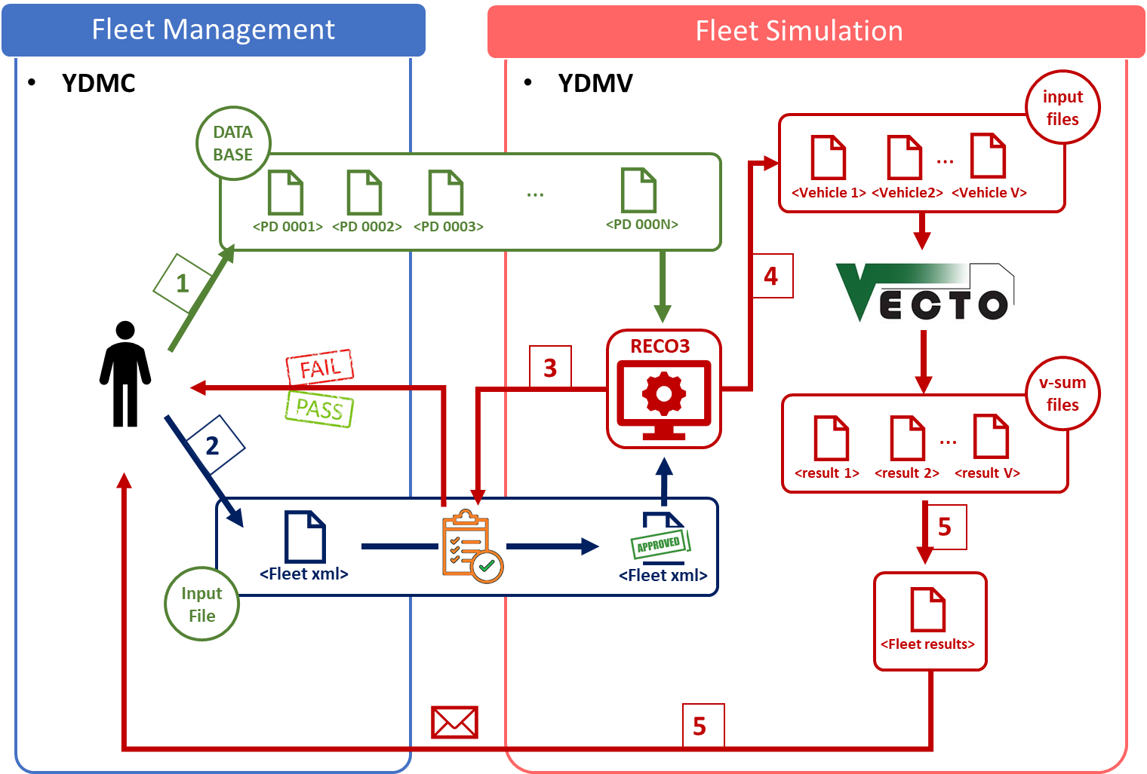

1. The user at YDMV receives Xml-files with component data that are imported to the database through the New Improvement Manager tool described in the previous section. If the component exists in the database, i.e. the PD-number is present in the database, the tool treats the new component as an update, and besides the data that is written to the database it also marks it with a reference that points to the original PD-number.

2. The user at YDMV receives a fleet file in Xml-format to be used in the simulation. It’s a rather big file and holds the whole fleet of 45k+ trucks. A roadmap is created in the Reco3 web application, and this file is then uploaded to the database with reference to the newly created roadmap.

3. If there are any errors when uploading, as of today Reco3 only states that an error occurred, then a tedious work starts for the developer who have to set break-points in the code to find out where the error occurs. Since it’s a rather big file it would be impossible to go through all of the 45k+ vehicles by hand. This means that today, the person doing this have to have developer tools installed, and needs to know how to work with them, e.g. Visual Studio dev environment. Also the person needs to know the code and how to program to be able to understand where to look, and how to interpret it. This should be avoided in a future refactoring and it should be made more user-friendly.

4. The user at YDMV opens the Roadmap in the Reco3 web application, and clicks on “Lock and Create”, which makes it ready for conversion to Vecto-format. The conversion usually takes 4 – 6 hours. When this is done, in the Reco3 web application you now click on the Simulate button, and the simulation process starts with the creation of V-Sum files. This takes around 4 days to complete with the computer power we have today.

5. When the simulation is done, the user at YDMV opens Sql Server Management Studio (tool for Sql Server database handling) in order to create the View described in the previous section above. When that is done the user e-mails the name of the newly created View to YDMC.

6. When the user at YDMV knows that YDMC have got the data, the data in the tables that were created in the conversion and simulation process is deleted.

# Future to-do list

* Simplify the work process so that YDMC can work with Reco3 by themselves
* Better error handling and logging so if something is wrong in the fleet file that is noted to the user
* Refactor the codebase so that it will be “impossible” to do errors when doing conversions and simulations in Reco3. As of today, Reco3 is very error prone, and the user must rigorously follow a document/guide with 75 steps in order to accomplish the simulation.
* When the simulation is finished, have the Excel-file being created automatically.
* Have an option either in Reco3 or in the New Improvement Manager to download the Excel-file.
* Due to the large amount of data created in the database, have an option, either in Reco3 or in the New Improvement Manager, to delete the data from the simulation after the Excel-file is created.
* Adding the possibility to do Vecto-simulations of Bus Chassis
* Adding the possibility to do Vecto-simulations of Bus Bodies
* Adding the possibility to do Vecto-simulations of BEVs
* Do an architectural assessment on how Reco3 can be moved to Amazon Web Services (AWS), which is the long-term Scania initiative for all Scania software. This work has been started, i.e. an Aurora database and an EC2 (cloud server) is set up for testing today, but this work has been postponed. Also, there might be other ways to go and a thorough work needs to be done here to decide what technology and services to use.